**Product Description**

MicroRNAs (miRNAs), also known as “mature miRNA” are small endogenous RNAs (approximately 20-24 nucleotides in length), non-coding RNA molecules that can inhibit protein expressions of target mRNAs, by interacting mainly to its 3’untranslated regions (3’UTR) and thus degrade mRNAs or inhibit translation. MicroRNAs have been implicated in critical processes including differentiation, apoptosis, proliferation, and the maintenance of cell and tissue identity; furthermore, their misexpression has been linked to cancer and other disease. MiRNA sponge is one of the tools developed to achieve miRNA loss-of-function by using multiple copies of complementary oligonucleotides expressed from plasmid or vectors based on adenoviruses, retroviruses and lentiviruses. Artificial miRNA sponges are transcripts with miRNA binding sites that can absorb endogenous miRNA (thus the name comes from). Families of miRNAs can be characterized by nucleotide identity at positions 2-8 of the miRNA, a region known as the seed sequence. MicroRNA sponges specifically inhibit miRNAs by direct base pairing in the seed region, such that a single sponge can be used to block an entire miRNA seed family. Here, we generated miRNA sponge by constructed with a puromycin resistant lentivirus expression vector, a CMV strong promoter, 10-14 miRNA binding sites separated by a spacer containing 4 nucleotide residues, 4 nucleotide bulge in the center of miRNA binding sites, destabilized GFP and mCherry reporter helpful to monitoring the effectiveness of the sponge. Alternatively, the repression of the endogenous miRNA can be measured at either d2EGFP/mCherry ratio or target protein level. As lentivirus-based miRNA sponge are used, the effective molecules produced by microRNA sponge method could be continuously synthesized in the cells, thus can give rise to long-term inhibition of the microRNA function. Besides, the use of the dual-fluorescence reporter or the puromycin resistance marker can provide assistance for establishing stable cell lines.

Vector maps of miRNA sponge expression plasmid and Product features

C:\Users\User04\Desktop\miRNA sponge_科技部\fig\Map-4.tif 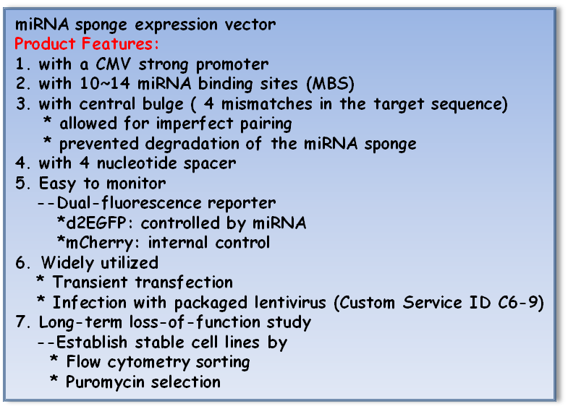



**Description:**

AS7w.mCherry-CMV d2EGFP miRNA sponge construction, a lentivector, stably expressed miRNA sponge for long-term loss-of-function studies:

1. The miRNA sponge sequence were inserted into the 3’UTR of a reporter gene encoding destabilized GFP driven by the Pol II CMV promoter;
2. The mCherry gene driven by hPGK in the construction was used as a control tracker for transfection or infection;
3. The plasmid can be digested by EcoRI and XmaI, which will remove the 1.9 kb stuffer and generate sticky ends for cloning of miRNA sponge oligos.

**Location of Features:**

|  |  |
| --- | --- |
| • RRE: nt 120-324 | • WPRE: nt 7117-7705 |
| • CMV promoter: nt 972-1540 | • HIV 3'LTR: nt 7797-8041 |
| • d2EGFP: nt 1681-2526 | • SV40 polyA: nt 8103-8233 |
| • Stuffer: nt 2552-4420 | • bla promoter: nt 9093-9191 |
| • cPPT: nt 4491-4608 | • Amp: nt 9192-10049 |
| • hPGK promoter: nt 4661-5167 | • Ori: nt 10253-10793 |
| • mCherry: nt 5192-5902 | • RSV promoter: nt 11278-11506 |
| • IRES: nt 5907-6509 | • HIV 5'LTR: nt 11507-11687 |
| • Puromycin(PAC): nt 6507-7106 | • Psi sequence: nt 11798-11842 |

**Note:**

d2EGFP sequencing primer (F): 5'-AGGTGGAGGAGCAGGATGAT-3'

**Protocol**

1. **miRNA sponge Contruction (Customized C6-14)**
2. **Plasmid DNA Preparation (RNAiCore/ Resources/ Plasmid preparation/ Purification of Transfection-Quality DNA)**
3. **Lentiviral miRNA sponge Production (Customized C6-9)**
4. **Plasmid transfection for functional analysis**
5. **Lentirival transduction for functional analysis**
6. **Lentiviral transduction for functional analysis**

5.1) Protocol

Day 1：Seed cells

Day 2：Transduction

In case the expression levels of the sponge are low and the levels of the endogenous miRNA of interest are high, testing transduced cells at multiplicity of infection (MOI) may help to achieve an optimal balance between the expression level of the sponge and the endogeneous miRNA. We recommend transducing cells at multiplicity of infection (MOI) = 1, 5, 10, 20, and 30 to determine the optimal miRNA expression.

Dya 2-3：Remove medium and replace with fresh growth medium

Dya 3+：Puromycin/FACS selection

Select transduced cells with medium containing puromycin. The appropriate puromycin concentration is specific to each cell lines and should be determined experimentally prior to selection using a kill curve. Since antibiotics are most effective when cells are actively dividing, we recommend splitting the cells 1:3 to 1:5, depending on the growth rate of your target cells (Be noted that some miRNA is essential for cell growth or viability) and continue incubating cells in selection medium for an additional 2 to 4 days. The transduced cells can be selected by puromycin or sorted by FACS in this constructed system.

Dya 5+：Assay transduced cells

Expand puromycin-selected or sorted cells stably expressing miRNA sponges and store the cell lines stock in liquid nitrogen. The infected target cells can be either analyzed for transient expression or selected for stable expression with puromycin. The destabilized GFP transcript levels normalized to those for mCherry were quantified to show the inhibition of miRNA by sponges.

**4) Plasmid transfection for functional analysis**

4.1) Protocol

Day 1：Seed cells

Day 2：Transfection

Check to make sure the cells should be 60-80% confluent prior to transfection. The transfection efficiency varies according to cell type and the transfection reagent used. The optimal conditions must be determined empirically. It is highly recommended to test a range of miRNA sponge plasmid concentration prior to transfection.

Dya 3+：Assay transfected cells

Harvest cells at 24-72 hrs after transfection. Replace the transfection medium with fresh medium if cell toxicity is observed after 24 hrs post-transfection. The optimal time for analysis of the miRNA sponge effect by transfection must be determined experimentally. This can be determined by performing a time-course experiment.